1. So far we saw how to authenticate a user means how to secure API Paths (URLs).
2. 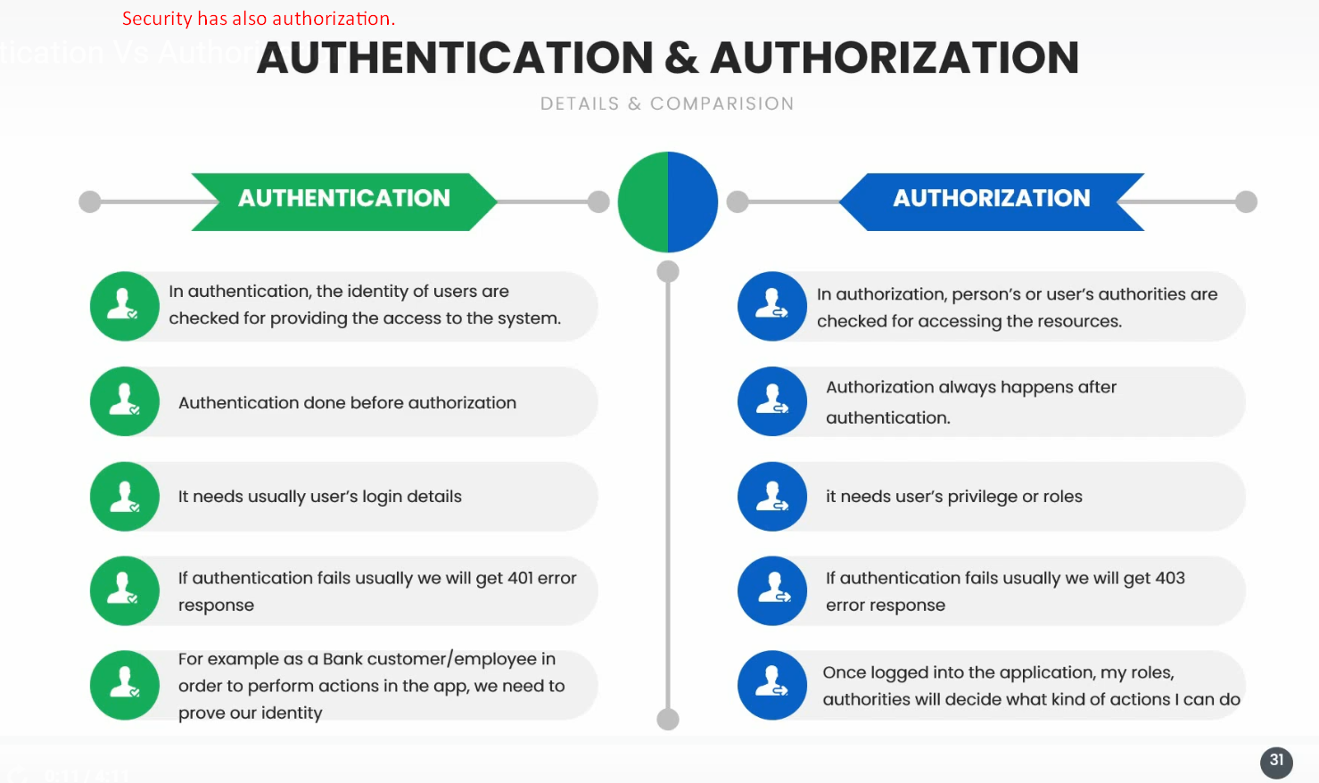
3. **Example**:
   1. You have flight ticket for Mumbai.
   2. First you need to identify your identity using ticket, SSN, Passport etc. 🡸 Authentication
   3. Then you go to the gate for Mumbai flight.
   4. You can’t take on other flight. 🡸 Authorization.